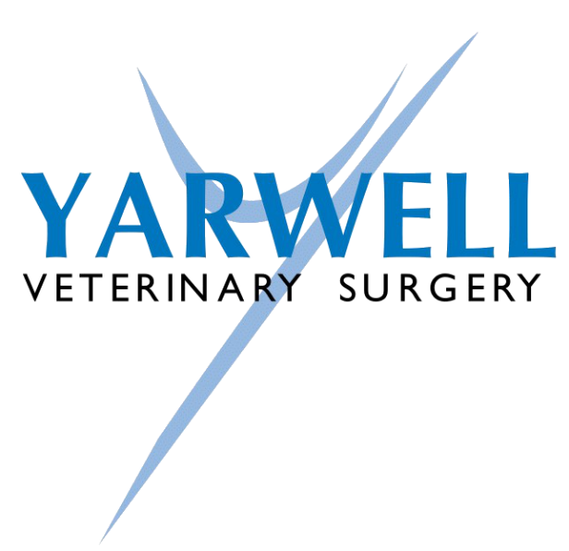

Healthy Pet Club for Dogs 2026
We are now offering 4 plans for dogs:
Essential
Annual routine vaccinations (covering against Distemper, Hepatitis, Leptospirosis and Parvo Virus)
Simparica Trio monthly (covering fleas, ticks, roundworm and lungworm)
6 monthly preventative health check
10% off additional vaccines (Rabies and Kennel Cough)
10% off Animal Health Certificates (for travel)
10% off routine dentals and neutering at Yarwell
10% off many long-term medications and many Pet Health Care products
5% off Behaviour Consultations
Essential Plus (NEW)
As Essential
“plus”
Prazitel quarterly tapeworm treatment
Premium
As Essential
“plus”
Monthly tapeworm treatment with Prazitel
Premium Bravecto
As Essential except using Bravecto – spot on or tablet every 3 months and monthly Milprazon. This is suitable for those dogs which are going to be used for breeding.
Kennel Cough
Kennel Cough can be added to any plan for a monthly supplement of £3.25

Complimentary Annual and 6 month (interim) health checks
These are wellness checks – they include a full clinical examination, including checking weight, body condition scoring, checking the ears, eyes and mouth. It includes a visual dental examination with a co-operative patient! We will also palpate the abdomen and listen to the heart and lungs. Nails can be clipped as necessary (with a co-operative patient). We can discuss diet, lifestyle etc and any health or behavioural concerns.
If any minor treatment is needed it will either be given and charged for at the time – e.g. cleaning ears or anal gland emptying. If anything further, or more involved treatment is recommended – such as blood tests or imaging, lump removals, dentals, investigation and treatment of behaviour issues etc., an ongoing plan will be discussed with you.
These appointments can be used as a medicine checks for stable conditions such as thyroid problems, heart, skin problems and arthritis. If blood tests are needed then no consult fee would be incurred - just the blood sampling fee. If a regular injection such as Librela or Cytopoint is needed then just the drug fee and an injection fee would be charged.
These appointments cannot be used for new problems, unstable on-going problems or as follow-up behaviour consults.

YARWELL HEALTHY PET CLUB MEMBERSHIP
Membership of our Healthy Pet Club for dogs and cats allows you to spread the cost of your pet’s essential vaccinations and routine parasite control throughout the year paying by affordable monthly installments. You can leave the scheme at any time, with no minimum contract. Additionally, membership provides you with various discounts on items like extra vaccinations, food, toys, and other pet accessories.
For anyone not wishing to join our Healthy Pet Club we can still offer a 25% discount on any full year’s supply of flea/worm products. Please ask for more details about these and any other services.

Please note that if you leave the scheme within the first year, when we work out any refunds/money owed, it is worked out on our standard and NOT our discounted fees. We will credit overpayments and invoice for any underpayments.

No refunds are available for products and services unclaimed.

